**DAILY ONLINE ACTIVITIES SUMMARY**

|  |  |  |  |  |  |  |  |
| --- | --- | --- | --- | --- | --- | --- | --- |
| **Date:** | **28-05-2020** | | | | **Name:** | **B.A.SOHANKUMAR** | |
| **Sem & Sec** | **4TH SEM A** | | | | **USN:** | **4AL18CS013** | |
| **Online Test Summary** | | | | | | | |
| **Subject** | | **1. MICRO CONTROLLER AND EMBEDDED SYSTEMS**  **2. AADALITHA KANNADA** | | | | | |
| **Max. Marks** | | **1. 20**  **2. 50** | | **Score** | | **1. 18**  **2. 25** | |
| **Certification Course Summary** | | | | | | | |
| **Course** | **INTRODUCTION TO ETHICAL HACKING** | | | | | | |
| **Certificate Provider** | | | **GREAT LEARNING ACADEMY** | **Duration** | | | **6 HOURS** |
| **Coding Challenges** | | | | | | | |
| **Problem Statement:1:C program to find DIGITALROOT of a number.** | | | | | | | |
| **Status: EXECUTED** | | | | | | | |
| **Uploaded the report in Github** | | | | **YES** | | | |
| **If yes Repository name** | | | | **LOCKDOWN CODING** | | | |
| **Uploaded the report in slack** | | | | **YES** | | | |

**ONLINE TEST DETAILS:**

1. The test was from 2nd module of MICRO CONTROLLER AND EMBEDDED SYSTEMS (18CS44).The time duration was 40 minutes from 12.00pm to 12.40pm.There were 20 questions of mcq type.score I received is 18/20.

2. The test was from all the modules of AADALITHA KANNADA(18KAK49) .The duration of the test was 50 minutes from 2.00pm to 2.50pm.50 questions of mcq type.score I received is 25/50.



SNAPSHOTS:MES SNAPSHOT: AADALITHA KANNADA

**CERTIFICATION COURSE DETAILS:**

**Course:** Introduction to ethical hacking.

Today I learnt about :

1.Ethical Hacking in Web Applications-Demonstration.

2.Ethical Hacking on Mobile Platforms-Demonstration.

3.What is Ethical Hacking.

Completed with course and took the quiz assessment.

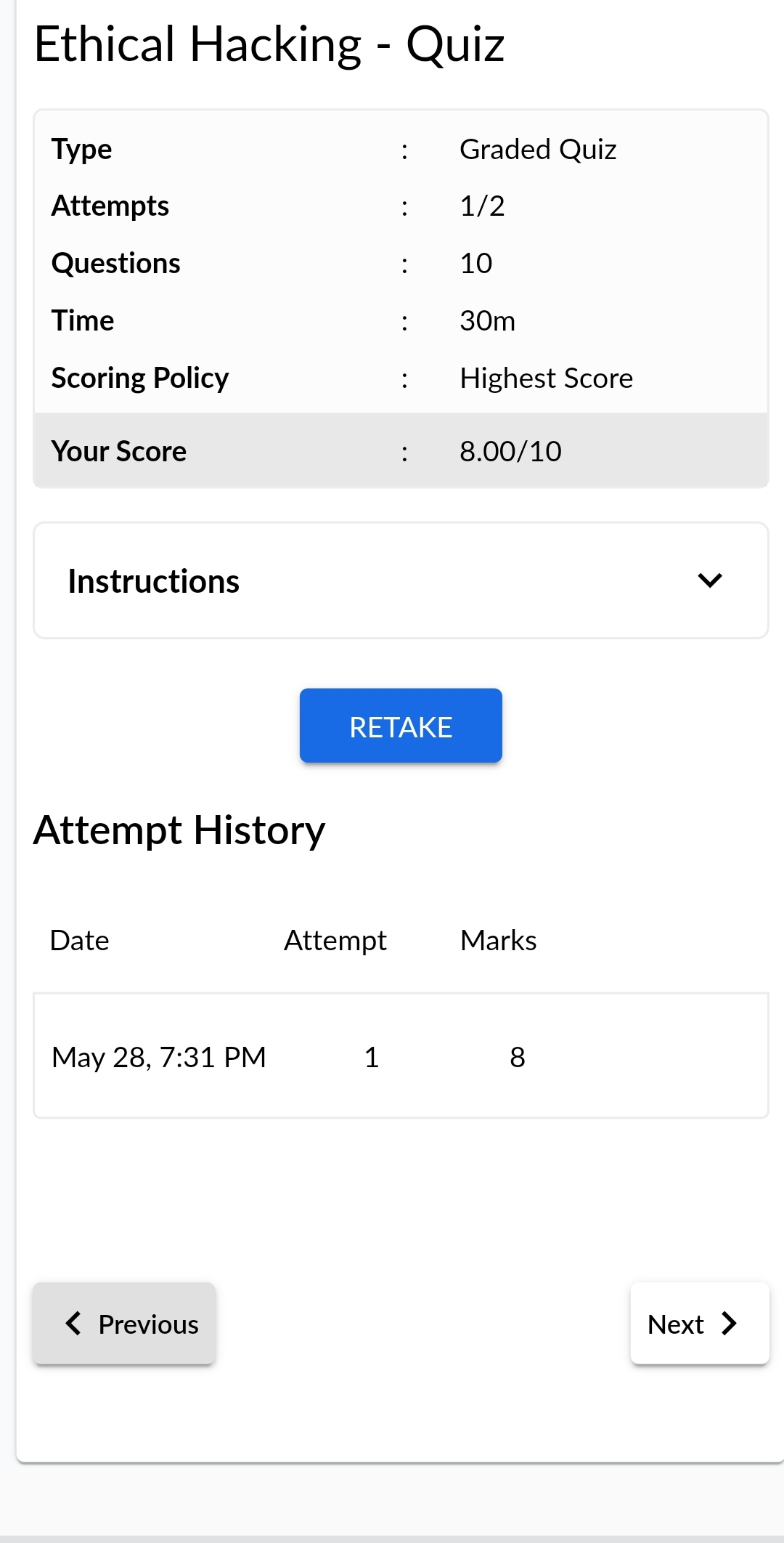



Above certificate is issued by great learning academy for the completion of INTRODUCTION TO ETHICAL HACKING course.

**CODING CHALLENGES:**

1.**C program to find DIGITALROOT of a number.**

Description:A digital root is the recursive sum of all the digits in a number. Given n, take the sum of the digits of n. If that value has more than one digit, continue reducing in this way until a single-digit number is produced. This is only applicable to the natural numbers.

digital_root(16)

=> 1 + 6

=> 7

digital_root(132189)

=> 1 + 3 + 2 + 1 + 8 + 9

=> 24 ...

=> 2 + 4

=> 6

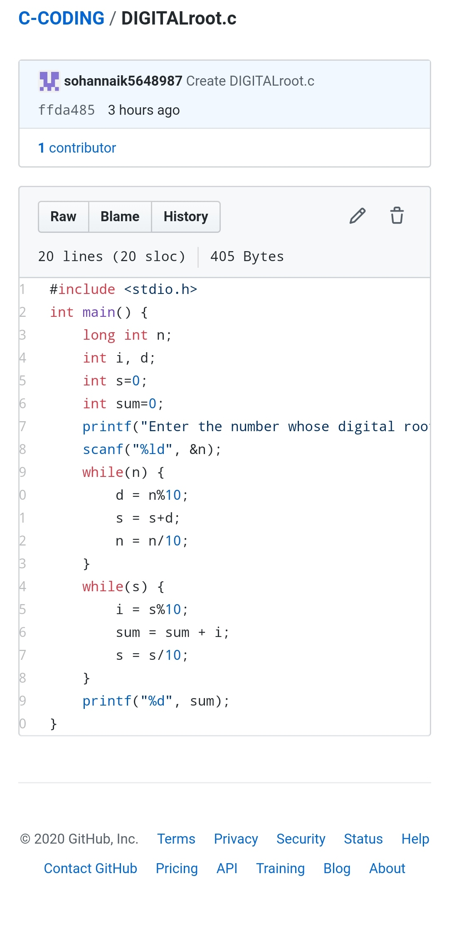

REPOSITORY LINK:https://github.com/sohannaik5648987/C-CODING